**Assignment 3**

**Question 1**

**Write a JavaScript program to display the reading status (i.e. display book name, author name,**

**and reading status) of the following books.**

**var library = [**

**{**

**author: 'Bill Gates',**

**title: 'The Road Ahead',**

**readingStatus: true**

**},**

**{**

**author: 'Steve Jobs',**

**title: 'Walter Isaacson',**

**readingStatus: true**

**},**

**{**

**author: 'Suzanne Collins',**

**title: 'Mockingjay: The Final Book of The Hunger Games',**

**readingStatus: false**

**}];**

**The output should look like this:**

**Already read 'Bill Gates' by The Road Ahead.**

**Already read 'Steve Jobs' by Walter Isaacson.**

**You still need to read 'Mockingjay: The Final Book of The Hunger Games' by Suzanne**

**Collins.**

**Ans.**

**Code:**

<!DOCTYPE html>

<html>

<head>

<meta charset=utf-8 />

<title>Book</title>

</head>

<body>

<script type="text/javascript">

var library = [

{

title: 'Bill Gates',

author: 'The Road Ahead',

readingStatus: true

},

{

title: 'Steve Jobs',

author: 'Walter Isaacson',

readingStatus: true

},

{

title: 'Mockingjay: The Final Book of The Hunger Games',

author: 'Suzanne Collins',

readingStatus: false

}];

for (var i = 0; i < library.length; i++)

{

var book = "'" + library[i].title + "'" + ' by ' + library[i].author + ".";

if (library[i].readingStatus) {

console.log("Already read " + book);

} else

{

console.log("You still need to read " + book);

}

}

</script>

</body>

</html>

**Output:**

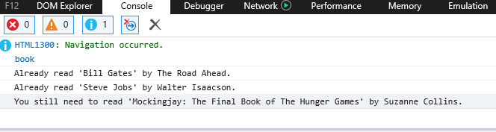

**Question 2**

**Write a javascript program that generates an alert "Not legal age to drive" if the driver age is**

**below 18 years old, if driver age is greater than or equal to 18, it generates an alert "Drive safe".**

**Ans.**

**Code:**

<!DOCTYPE HTML>

<html>

<head>

<title>Sum</title>

</head>

<body>

<script type="text/javascript">

var age = prompt("Enter Age : ");

if(age>=18)

{

alert("Drive Safe");

}

else

{

alert("Not legal age to drive");

}

</script>

</body>

</html>

**Output:**

